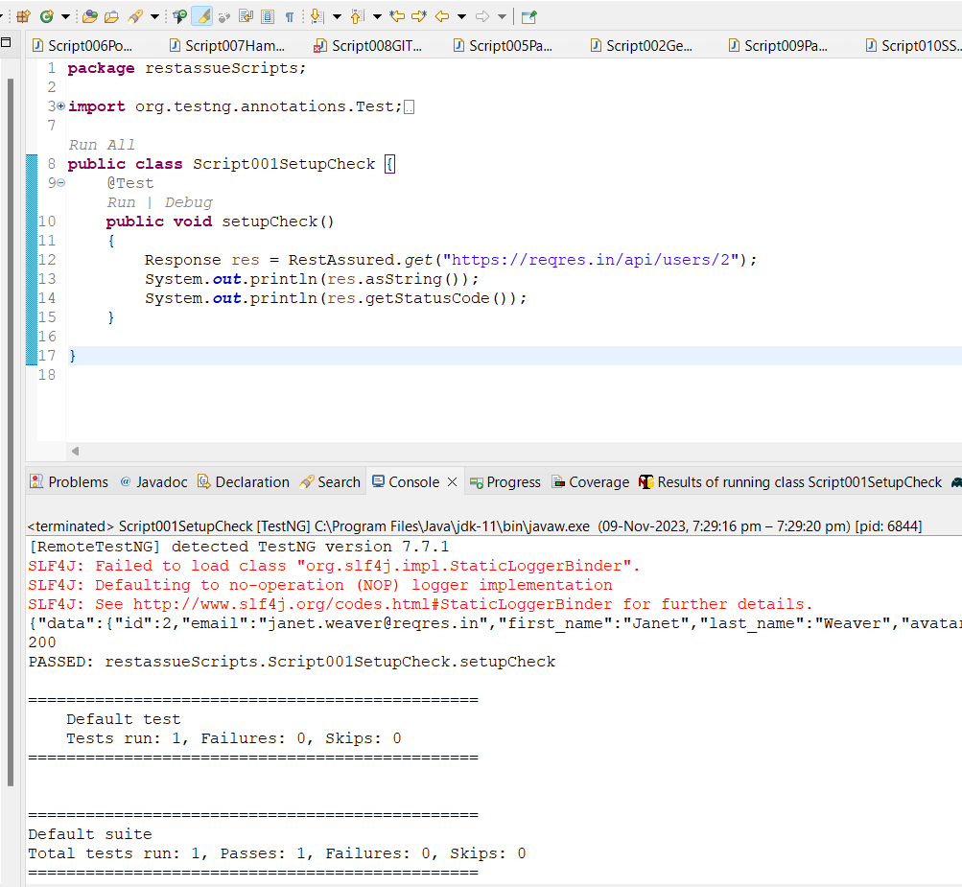

**package** restassueScripts;

**import** org.testng.annotations.Test;

**import** io.restassured.RestAssured;

**import** io.restassured.response.Response;

**public** **class** Script001SetupCheck {

@Test

**public** **void** setupCheck()

{

Response res = RestAssured.*get*("https://reqres.in/api/users/2");

System.***out***.println(res.asString());

System.***out***.println(res.getStatusCode());

}

}

**POML-FILE**

<?xml version="1.0" encoding="UTF-8"?>

<project xmlns="http://maven.apache.org/POM/4.0.0" xmlns:xsi="http://www.w3.org/2001/XMLSchema-instance"

xsi:schemaLocation="http://maven.apache.org/POM/4.0.0 http://maven.apache.org/xsd/maven-4.0.0.xsd">

<modelVersion>4.0.0</modelVersion>

<groupId>ATE-phase3-RestAssured</groupId>

<artifactId>ATE-phase3-RestAssured</artifactId>

<version>0.0.1-SNAPSHOT</version>

<name>ATE-phase3-RestAssured</name>

<!-- FIXME change it to the project's website -->

<url>http://www.example.com</url>

<properties>

<project.build.sourceEncoding>UTF-8</project.build.sourceEncoding>

<maven.compiler.source>1.7</maven.compiler.source>

<maven.compiler.target>1.7</maven.compiler.target>

</properties>

<dependencies>

<!-- https://mvnrepository.com/artifact/io.rest-assured/rest-assured -->

<dependency>

<groupId>io.rest-assured</groupId>

<artifactId>rest-assured</artifactId>

<version>5.3.0</version>

<scope>test</scope>

</dependency>

<!-- https://mvnrepository.com/artifact/io.rest-assured/rest-assured-common -->

<dependency>

<groupId>io.rest-assured</groupId>

<artifactId>rest-assured-common</artifactId>

<version>5.3.0</version>

</dependency>

<!-- https://mvnrepository.com/artifact/io.rest-assured/rest-assured-all -->

<dependency>

<groupId>io.rest-assured</groupId>

<artifactId>rest-assured-all</artifactId>

<version>5.3.0</version>

<scope>test</scope>

</dependency>

<!-- https://mvnrepository.com/artifact/io.rest-assured/json-path -->

<dependency>

<groupId>io.rest-assured</groupId>

<artifactId>json-path</artifactId>

<version>5.3.0</version>

<scope>test</scope>

</dependency>

<!-- https://mvnrepository.com/artifact/org.json/json -->

<dependency>

<groupId>org.json</groupId>

<artifactId>json</artifactId>

<version>20180813</version>

</dependency>

<!-- https://mvnrepository.com/artifact/org.hamcrest/hamcrest -->

<dependency>

<groupId>org.hamcrest</groupId>

<artifactId>hamcrest</artifactId>

<version>2.2</version>

<scope>test</scope>

</dependency>

<!-- https://mvnrepository.com/artifact/com.fasterxml.jackson.core/jackson-databind -->

<dependency>

<groupId>com.fasterxml.jackson.core</groupId>

<artifactId>jackson-databind</artifactId>

<version>2.15.2</version>

</dependency>

<!-- https://mvnrepository.com/artifact/org.testng/testng -->

<dependency>

<groupId>org.testng</groupId>

<artifactId>testng</artifactId>

<version>7.7.1</version>

<scope>test</scope>

</dependency>

<dependency>

<groupId>junit</groupId>

<artifactId>junit</artifactId>

<version>4.11</version>

<scope>test</scope>

</dependency>

<!-- https://mvnrepository.com/artifact/io.cucumber/cucumber-java -->

<dependency>

<groupId>io.cucumber</groupId>

<artifactId>cucumber-java</artifactId>

<version>7.10.1</version>

</dependency>

<!-- https://mvnrepository.com/artifact/io.cucumber/cucumber-java -->

<dependency>

<groupId>io.cucumber</groupId>

<artifactId>cucumber-junit</artifactId>

<version>7.10.1</version>

<scope>test</scope>

</dependency>

<!-- https://mvnrepository.com/artifact/io.cucumber/cucumber-java -->

<dependency>

<groupId>io.cucumber</groupId>

<artifactId>cucumber-core</artifactId>

<version>7.10.1</version>

</dependency>

<dependency>

<groupId>org.seleniumhq.selenium</groupId>

<artifactId>selenium-java</artifactId>

<version>4.11.0</version>

</dependency>

<!-- https://mvnrepository.com/artifact/io.github.bonigarcia/webdrivermanager -->

<dependency>

<groupId>io.github.bonigarcia</groupId>

<artifactId>webdrivermanager</artifactId>

<version>5.4.1</version>

</dependency>

</dependencies>

<build>

<pluginManagement><!-- lock down plugins versions to avoid using Maven defaults (may be moved to parent pom) -->

<plugins>

<!-- clean lifecycle, see https://maven.apache.org/ref/current/maven-core/lifecycles.html#clean_Lifecycle -->

<plugin>

<artifactId>maven-clean-plugin</artifactId>

<version>3.1.0</version>

</plugin>

<!-- default lifecycle, jar packaging: see https://maven.apache.org/ref/current/maven-core/default-bindings.html#Plugin_bindings_for_jar_packaging -->

<plugin>

<artifactId>maven-resources-plugin</artifactId>

<version>3.0.2</version>

</plugin>

<plugin>

<artifactId>maven-compiler-plugin</artifactId>

<version>3.8.0</version>

</plugin>

<plugin>

<artifactId>maven-surefire-plugin</artifactId>

<version>2.22.1</version>

</plugin>

<plugin>

<artifactId>maven-jar-plugin</artifactId>

<version>3.0.2</version>

</plugin>

<plugin>

<artifactId>maven-install-plugin</artifactId>

<version>2.5.2</version>

</plugin>

<plugin>

<artifactId>maven-deploy-plugin</artifactId>

<version>2.8.2</version>

</plugin>

<!-- site lifecycle, see https://maven.apache.org/ref/current/maven-core/lifecycles.html#site_Lifecycle -->

<plugin>

<artifactId>maven-site-plugin</artifactId>

<version>3.7.1</version>

</plugin>

<plugin>

<artifactId>maven-project-info-reports-plugin</artifactId>

<version>3.0.0</version>

</plugin>

</plugins>

</pluginManagement>

</build>

</project>